EX NO: 6

15/09/2021

**COUNTING OF N COINS IN ALL COMBINATIONS**

**AIM:**

To write a shell program to find the different possibilities of arranging coins with the available coins and quantiy.

**PROGRAM:**

**Source Code:**

#!/bin/bash

echo Combination of coins

coins=(1 2 5)

quantity=(5 3 2)

echo The coins available are: ${coins[@]}

echo The quantity of those coins are: ${quantity[@]}

echo Enter the total amount:

read total

for i in {0..5}

do

for j in {0..3}

do

for k in {0..2}

do

a=0 b=0 c=0 d=0

a=`expr $i \* 1`

b=`expr $j \* 2`

c=`expr $k \* 5`

d=$((a + b + c))

if [[ $d -eq $total ]]

then

echo [1 rupee coins]:$i [2 rupee coins]:$j [5 rupee coins]:$k

fi

done

done

done

**Output:**

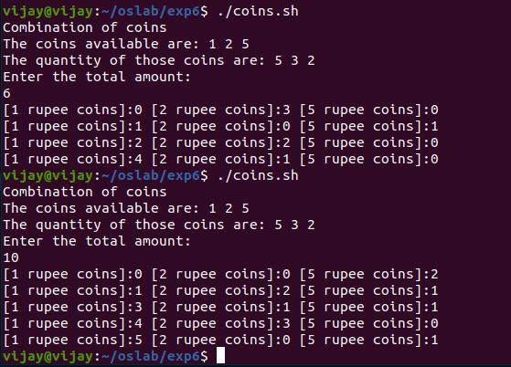

**RESULT:**

Hence a shell program to find out the different possibilities to arrange the coins with the available coins and quantity is created and the output has been verified.